

Final Project: Lab

Timothy Victori



Timothy Victori

Engineering Department Arizona State University

IFT320: Managing the Cloud

Rahul Kashyap

May 2, 2025

**Final Project: Lab**

**Figure 1:**

*Security Group VictoriFP SG being created*

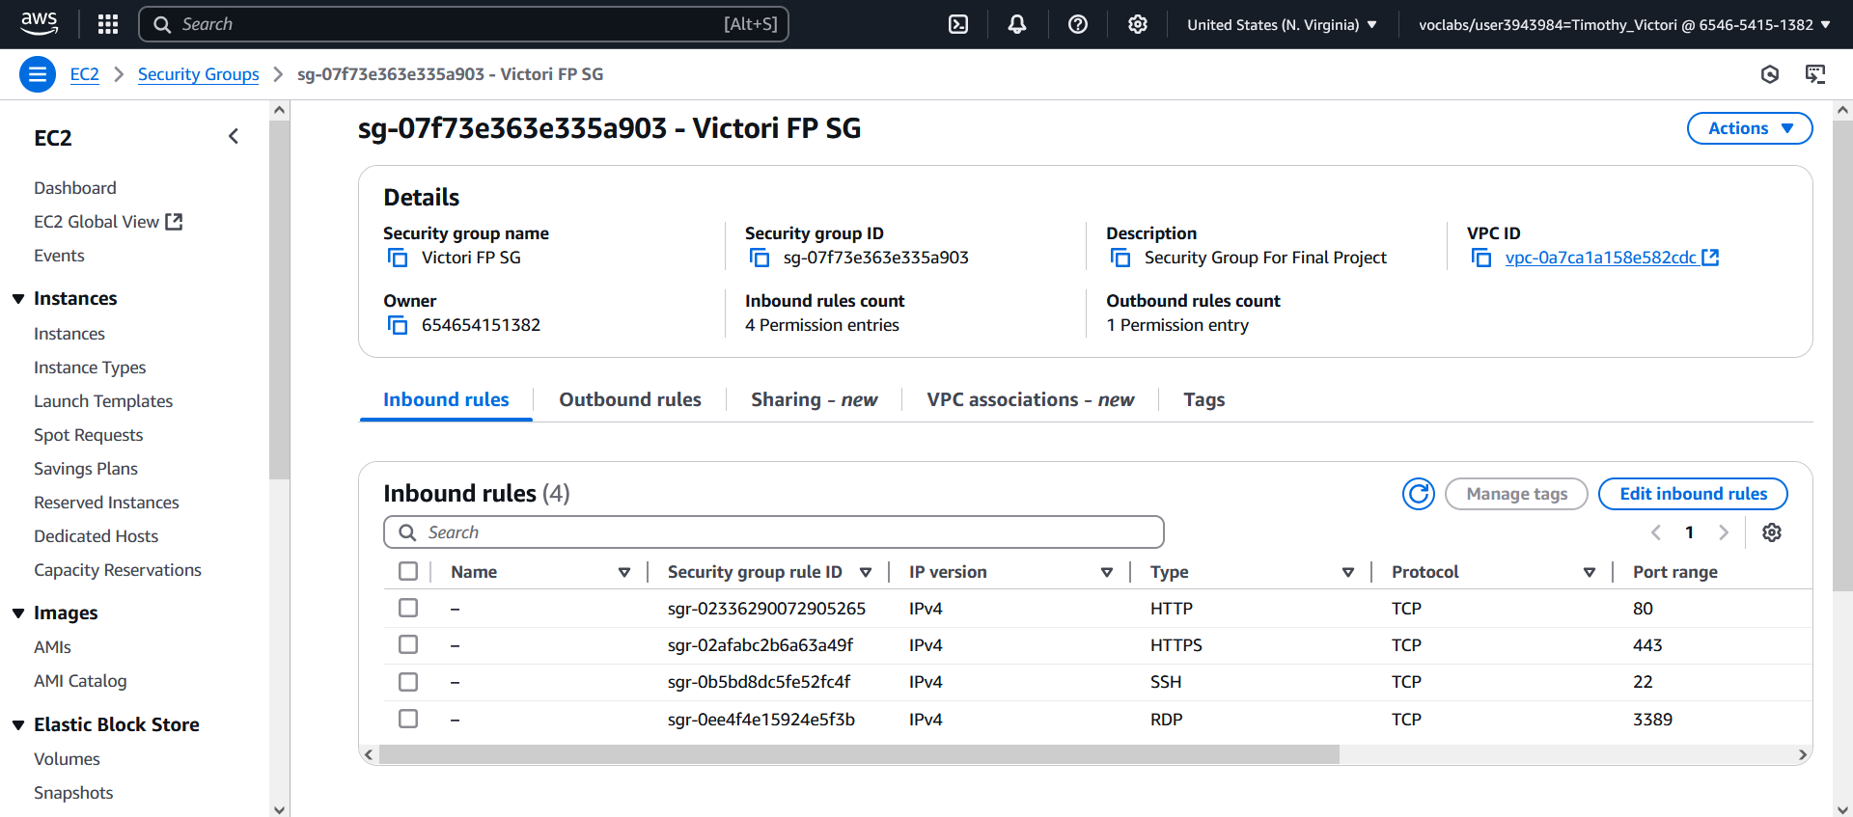

**Figure 2:**

*VictoriFP1 Summary*

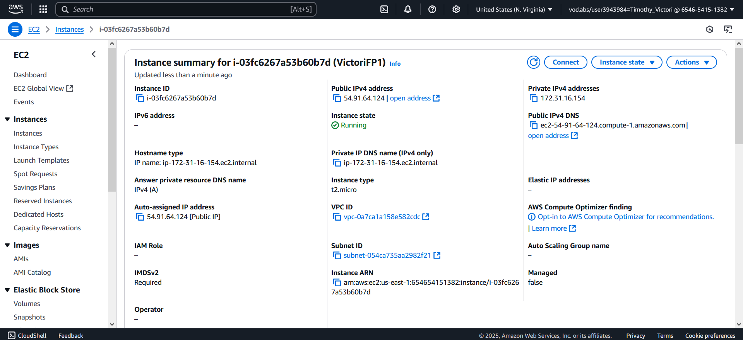

**Figure 3:**

*VictoriFP1 Volumes*

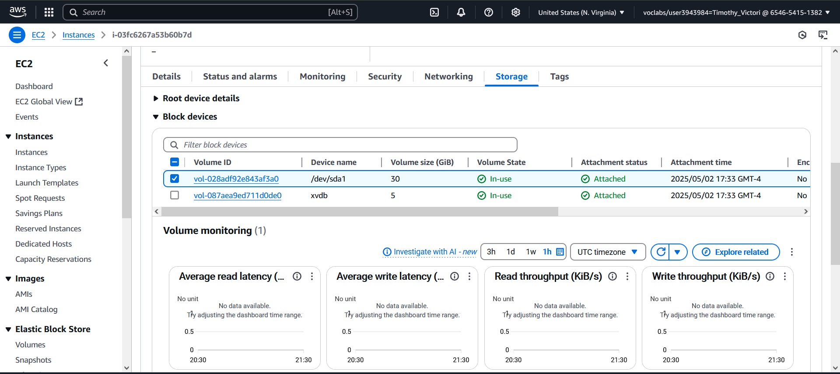

**Figure 4:**

*VictoriFP1 Security Groups*

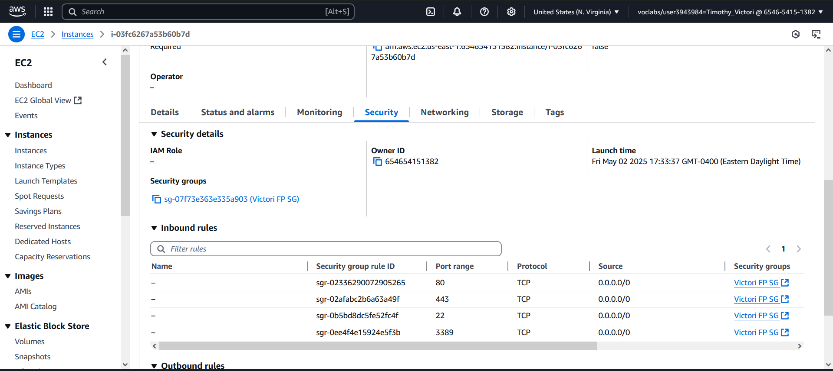

**Figure 5:**

*VictoriFP2 Summary*

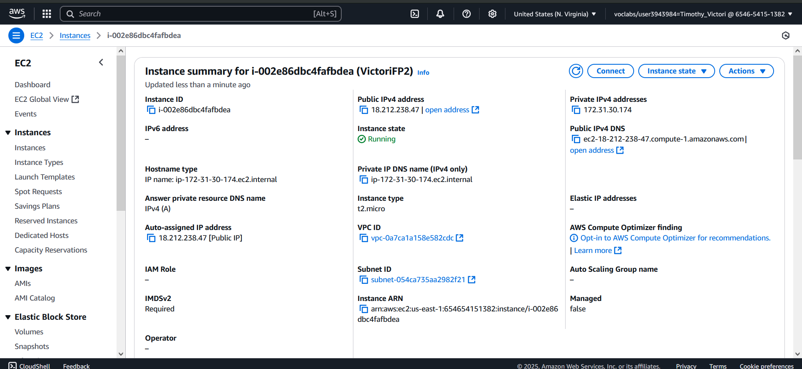

**Figure 6:**

*VictoriFP2 Volumes*

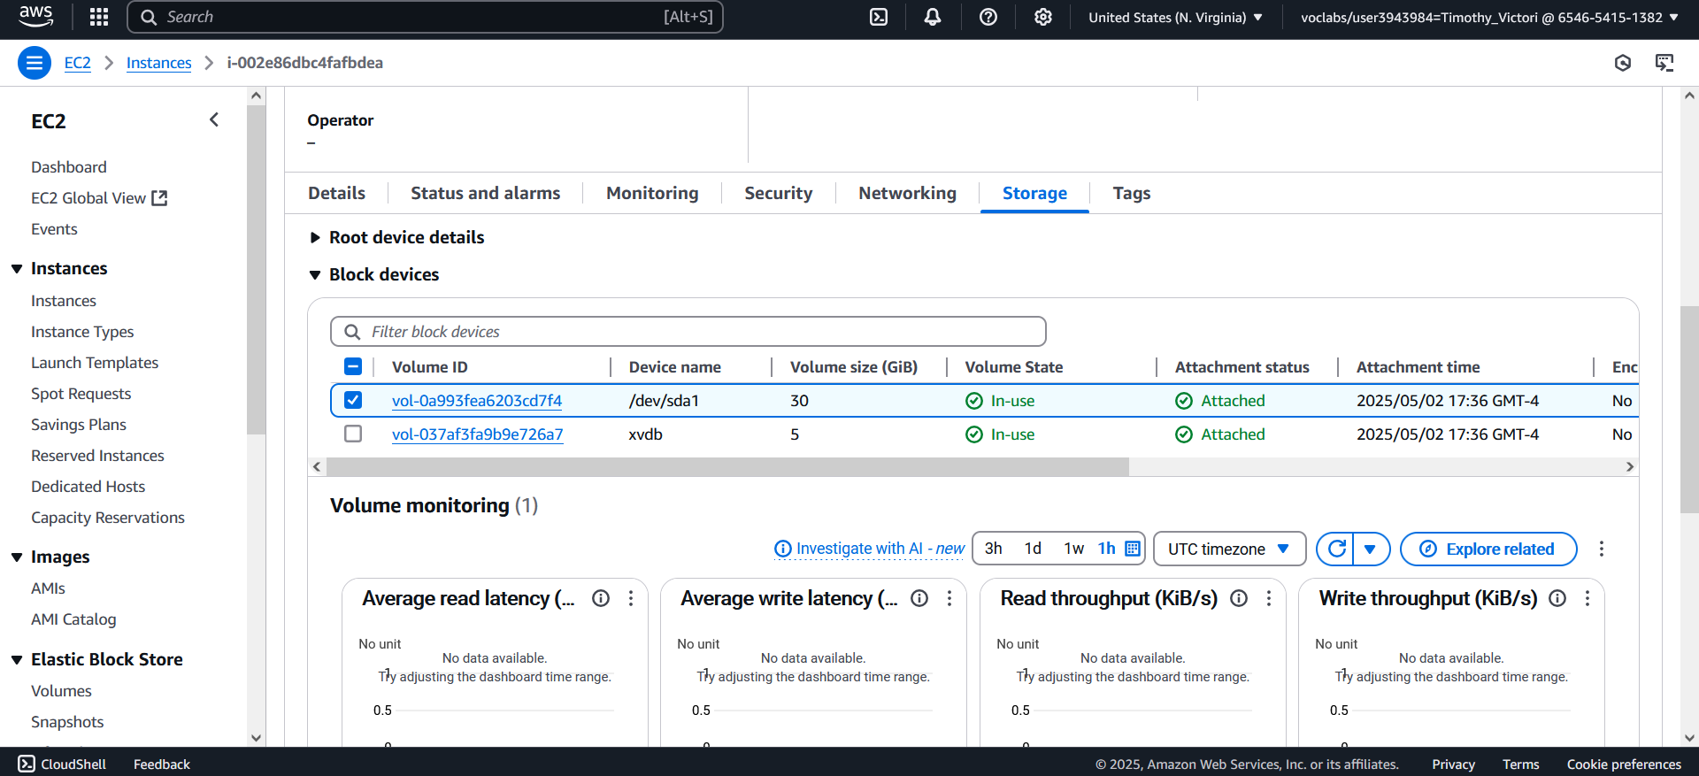

**Figure 7:**

*VictoriFP2 Security Groups*

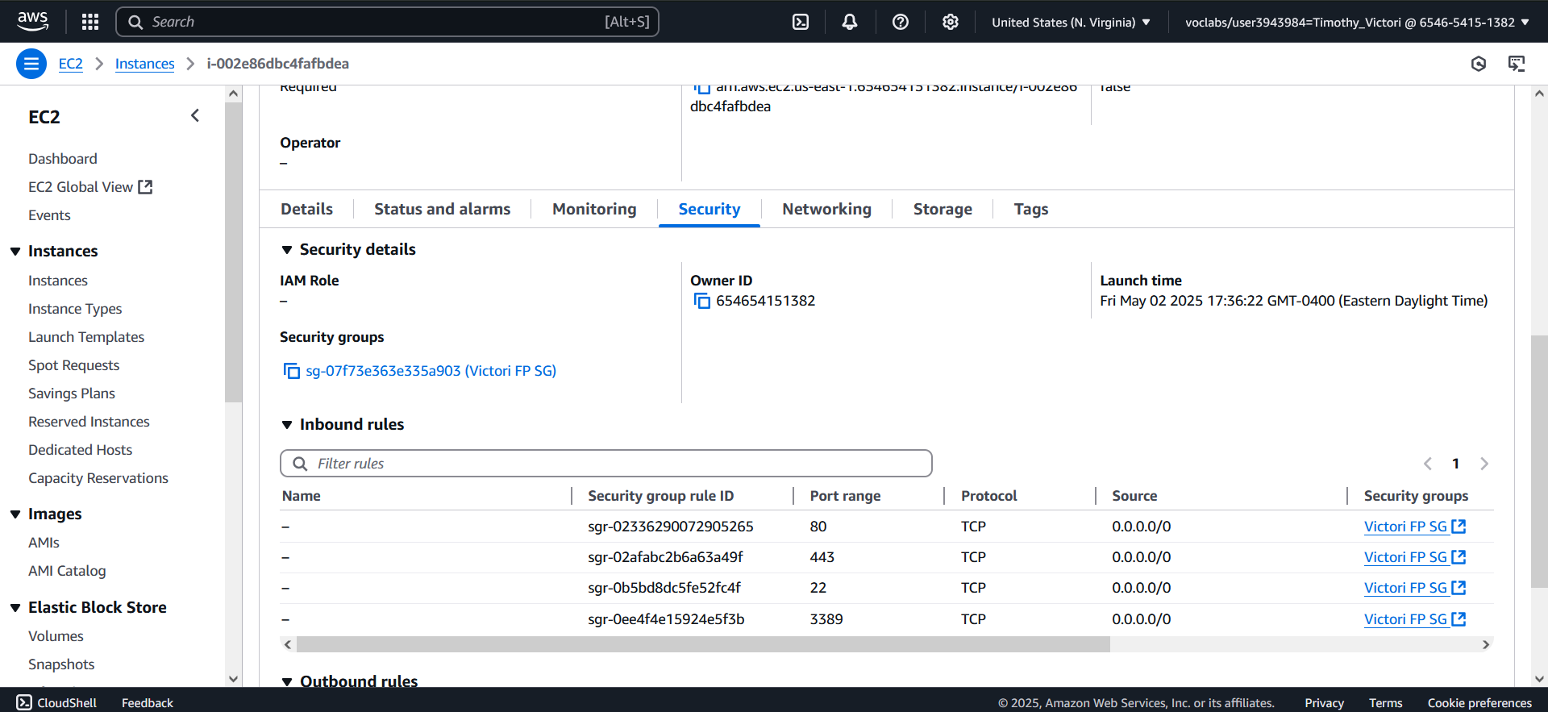

**Figure 8:**

*VictoriFP1 RDP Running with machine name VictoriFP1*

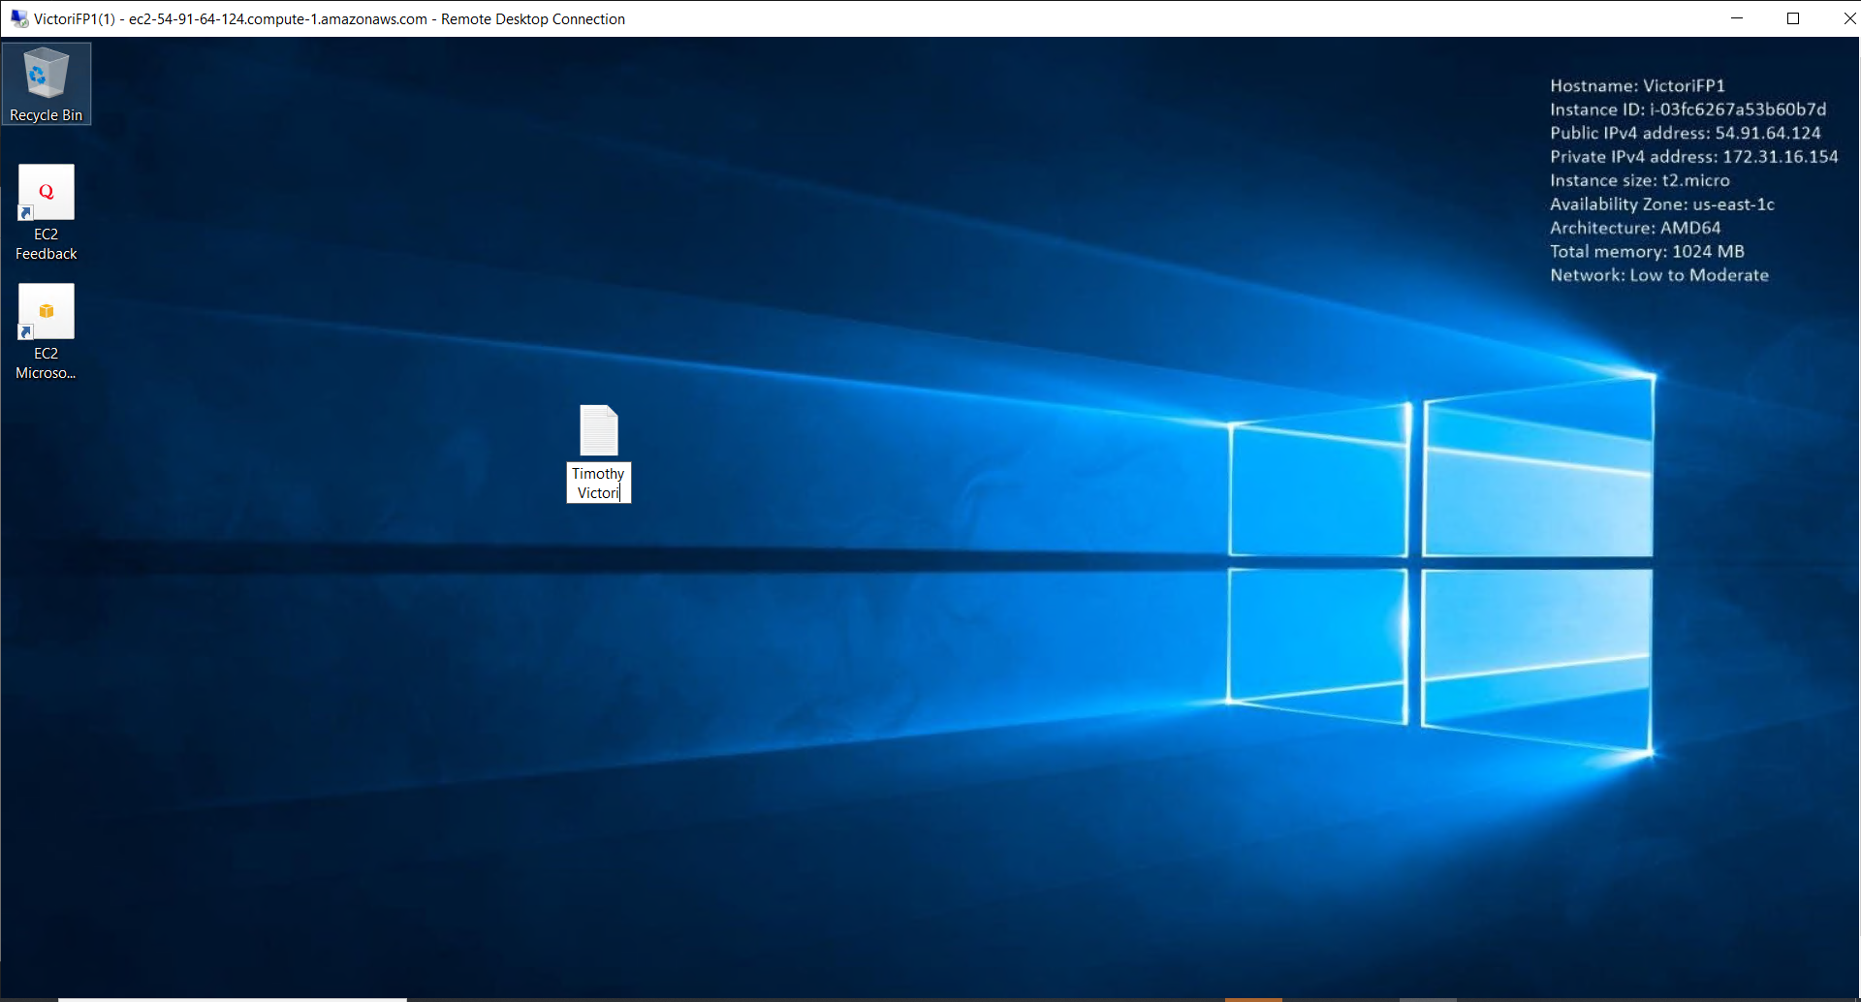

**Figure 8:**

*Disk Management of VictroiFP1 showing partition D: being available*

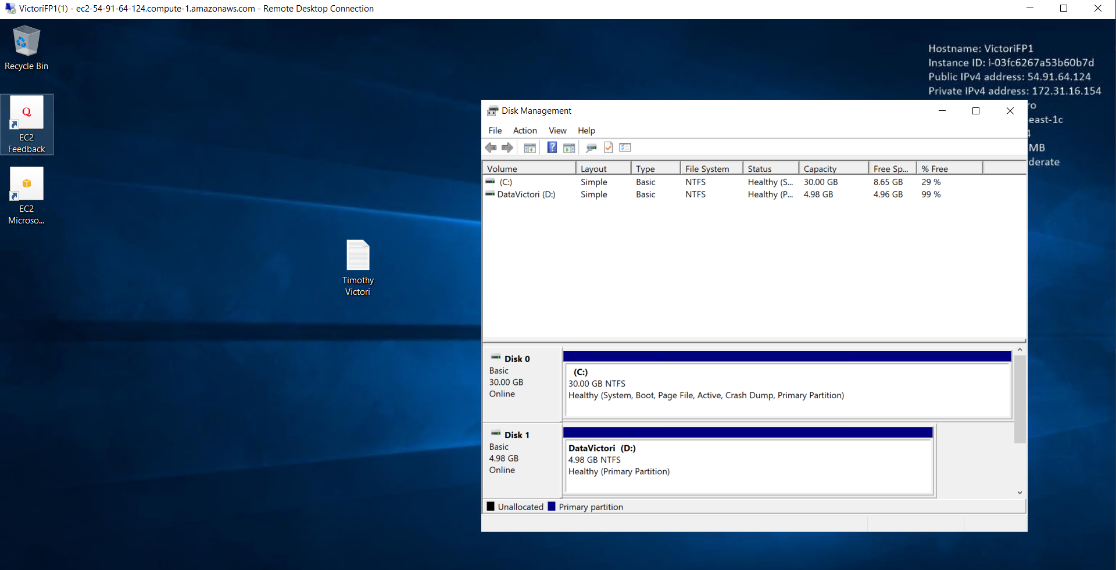

**Figure 9:**

*Server Webpage Made with IIS* 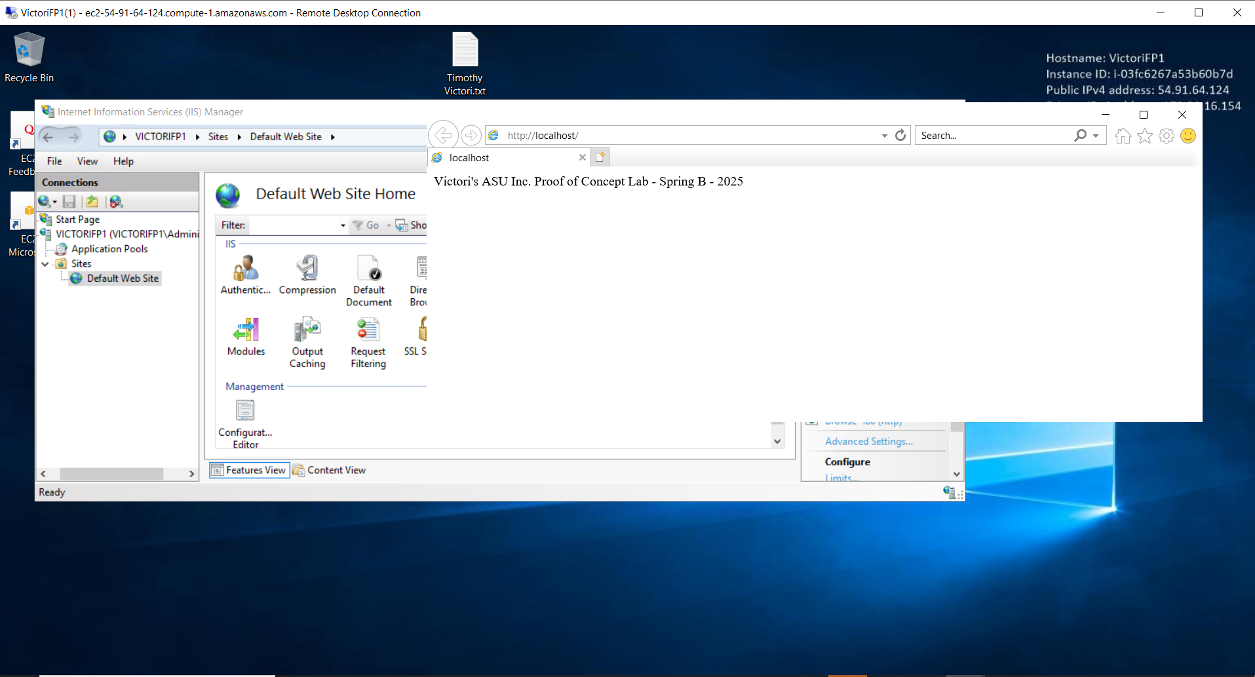

**Figure 10:**

*IIS Installed on VictoriFP1*

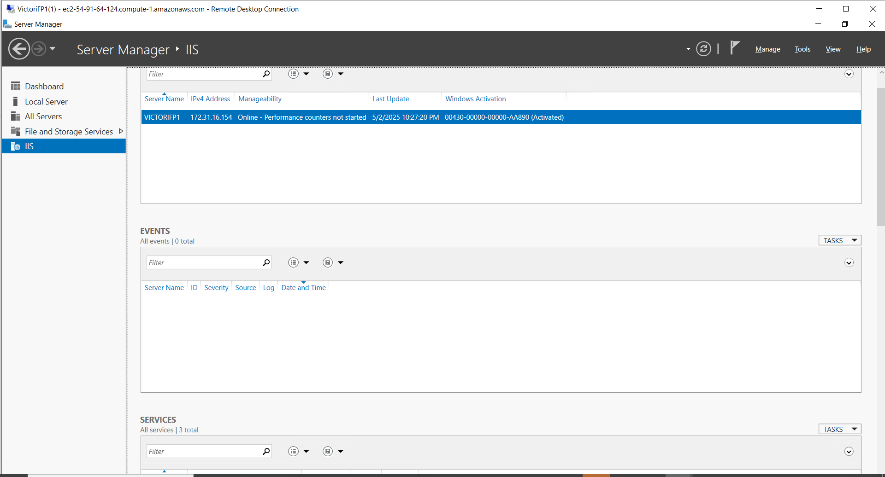

**Figure 11:**

*VictoriFP2 connected via RDP with the name VictoriFP2 in Windows*

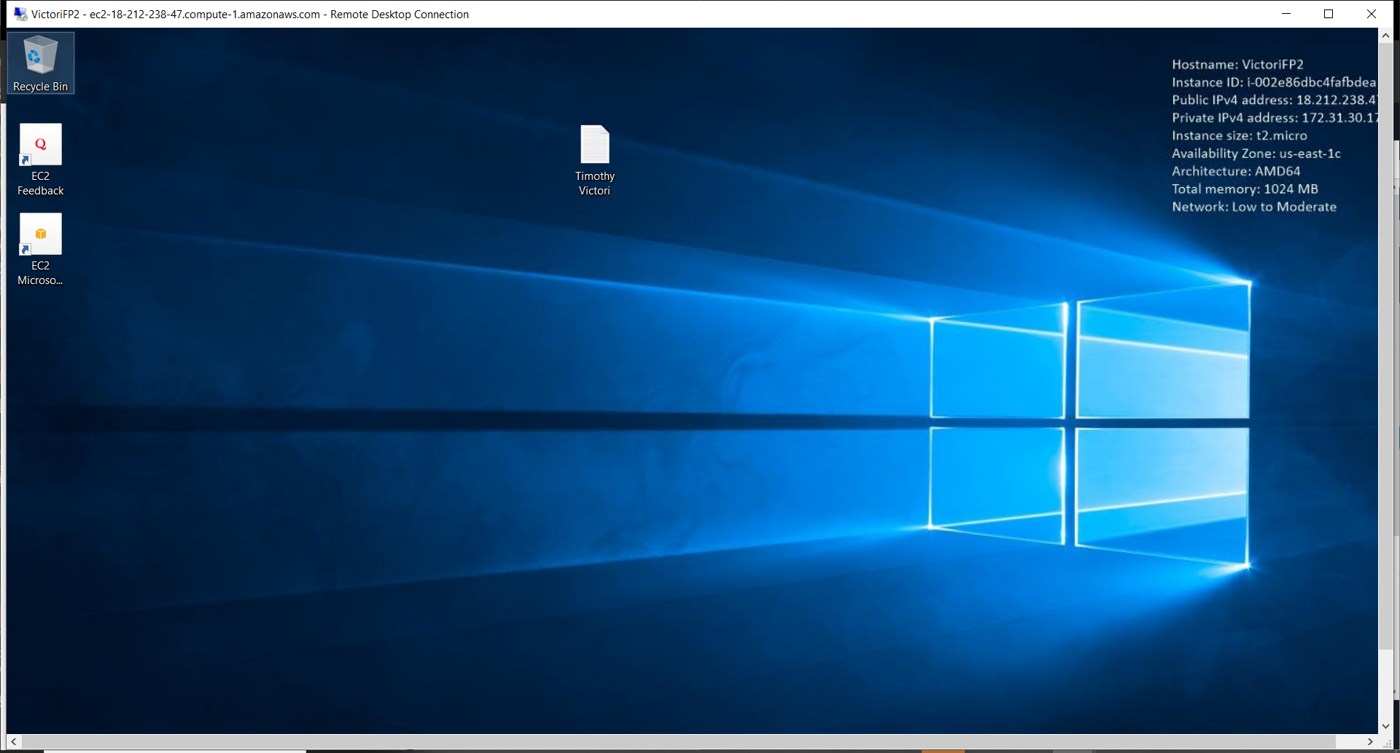

**Figure 12:**

*Disk Management of VictroiFP2 showing partition D: being available*

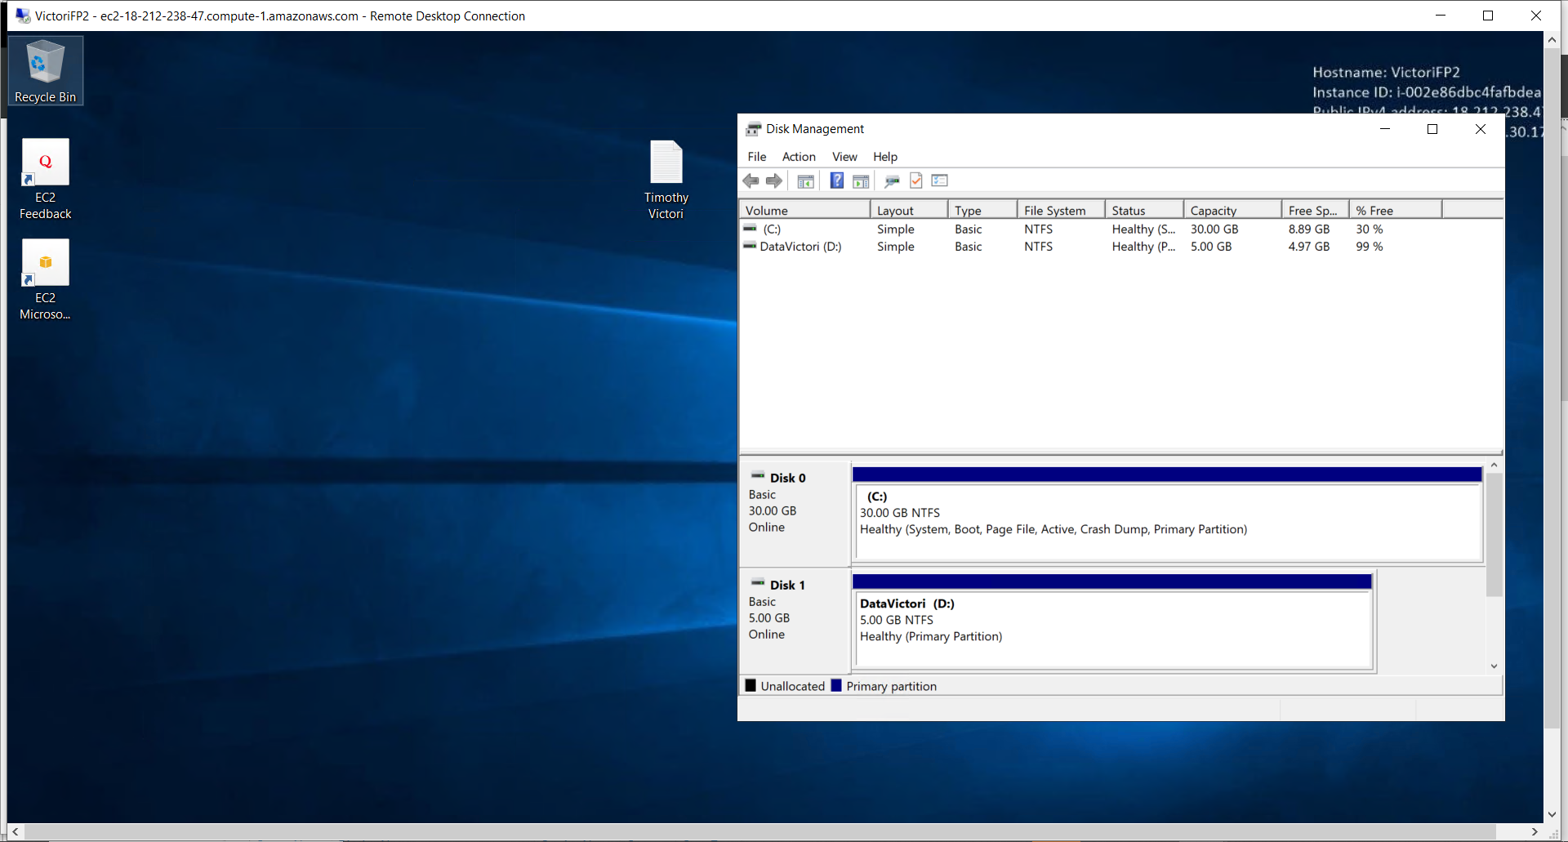

**Figure 13:**

*IIS Installed on VictoriFP2*

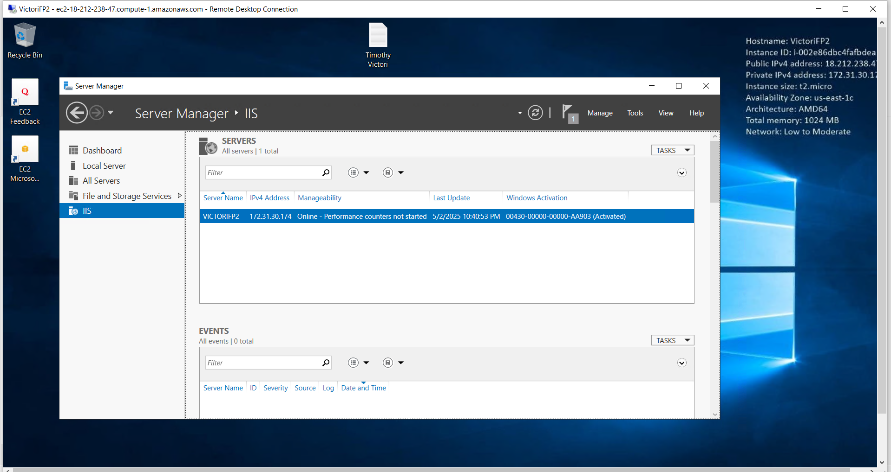

**Figure 14:**

*Server Webpage Made with IIS*

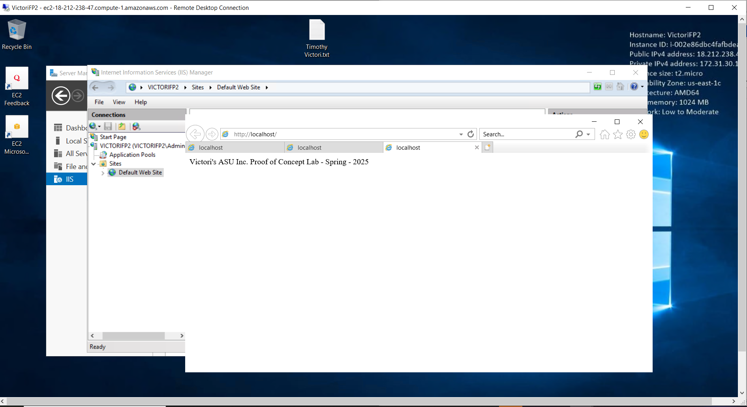**Figure 15:**

*VictoriFPTargetList Target Group*

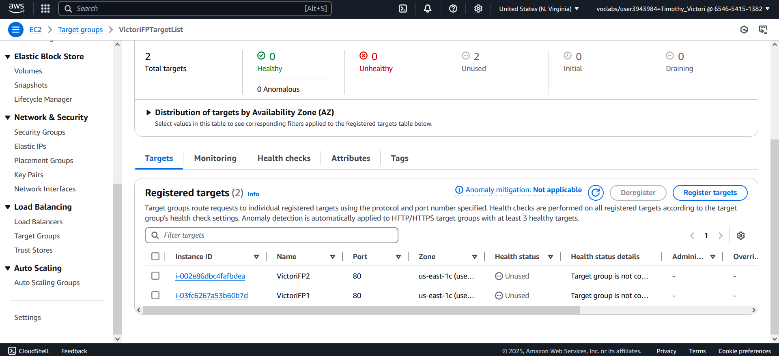

**Figure 16:**

*Target Group Selection*

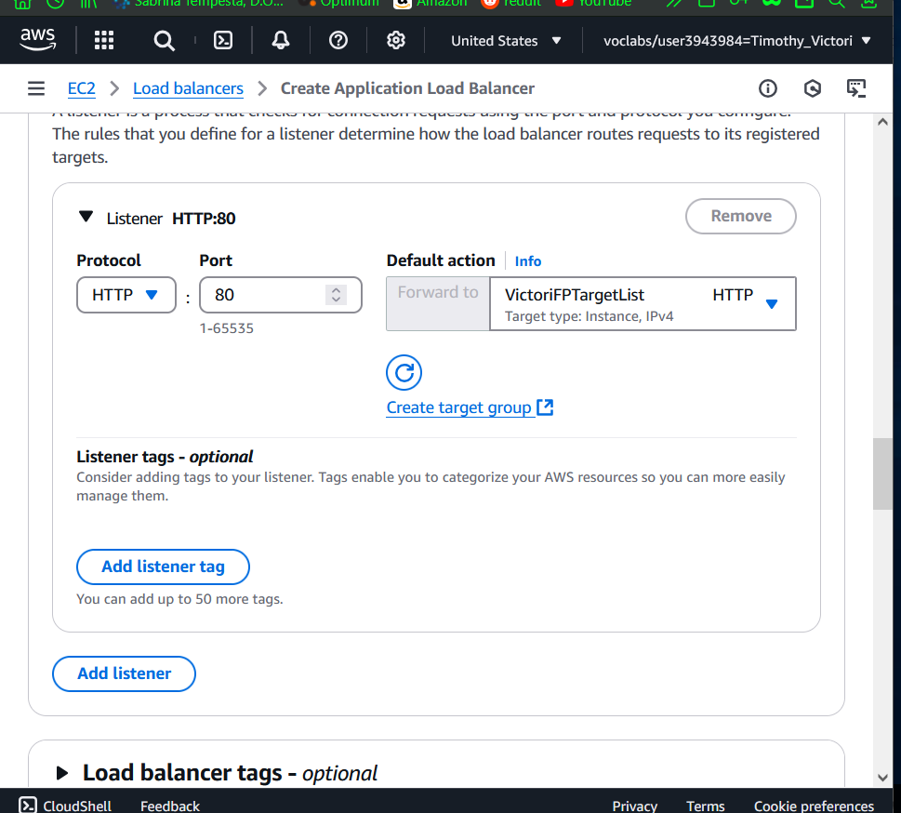

**Figure 17:**

*Load balancer VictoriFPLB*

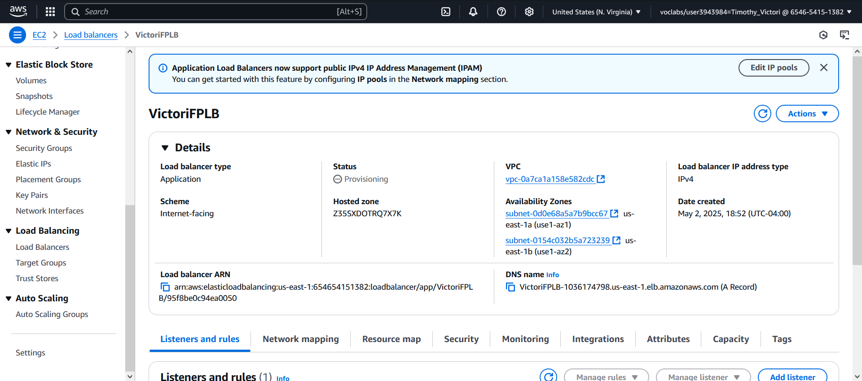

**Figure 18:**

*Load balancer VictoriFPLB Targets*

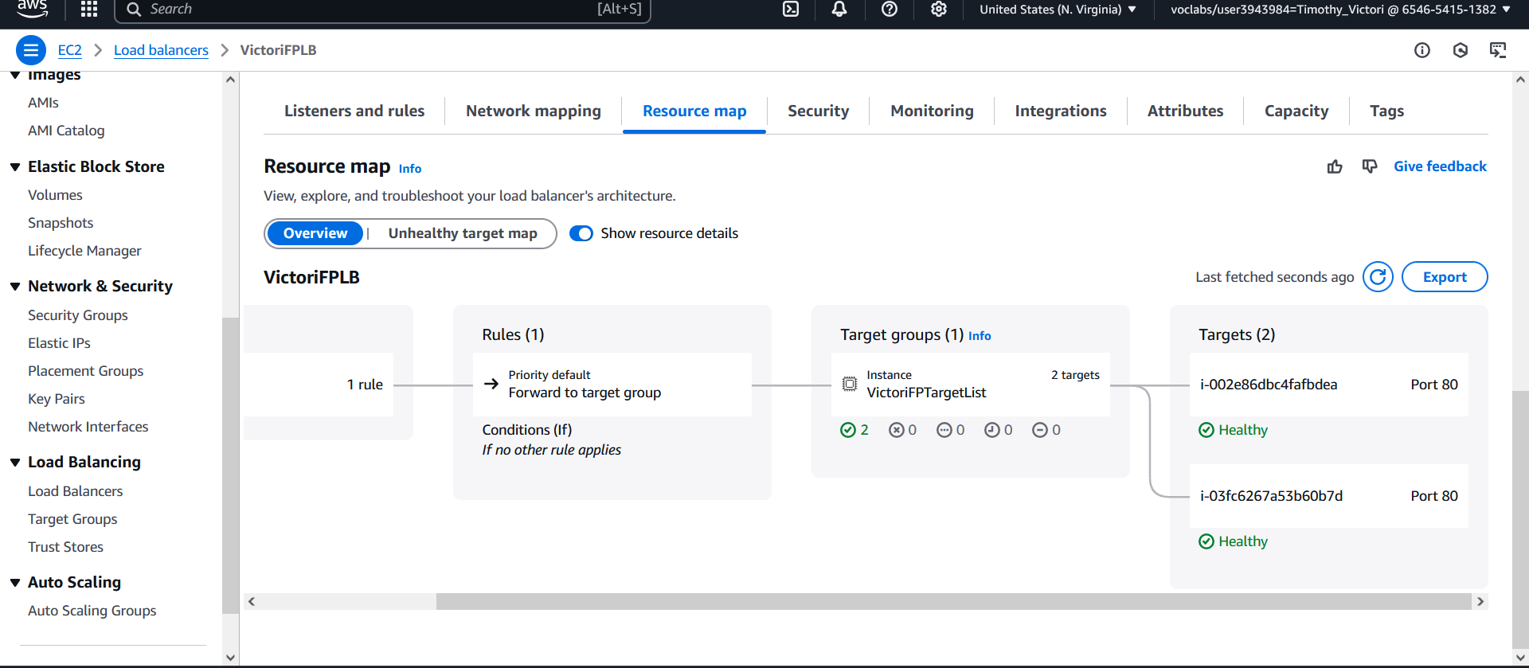

**Figure 19:**

*Load balancer VictoriFPLB Webpage access*

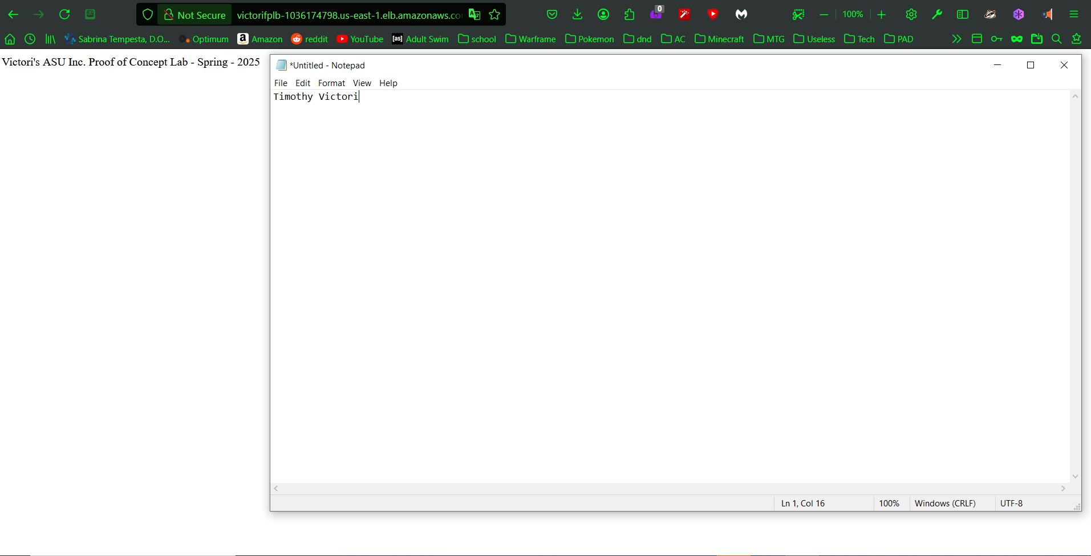

**Figure 20:**

*Route53 hosted zone using the domain IFT320Spring2025.com*

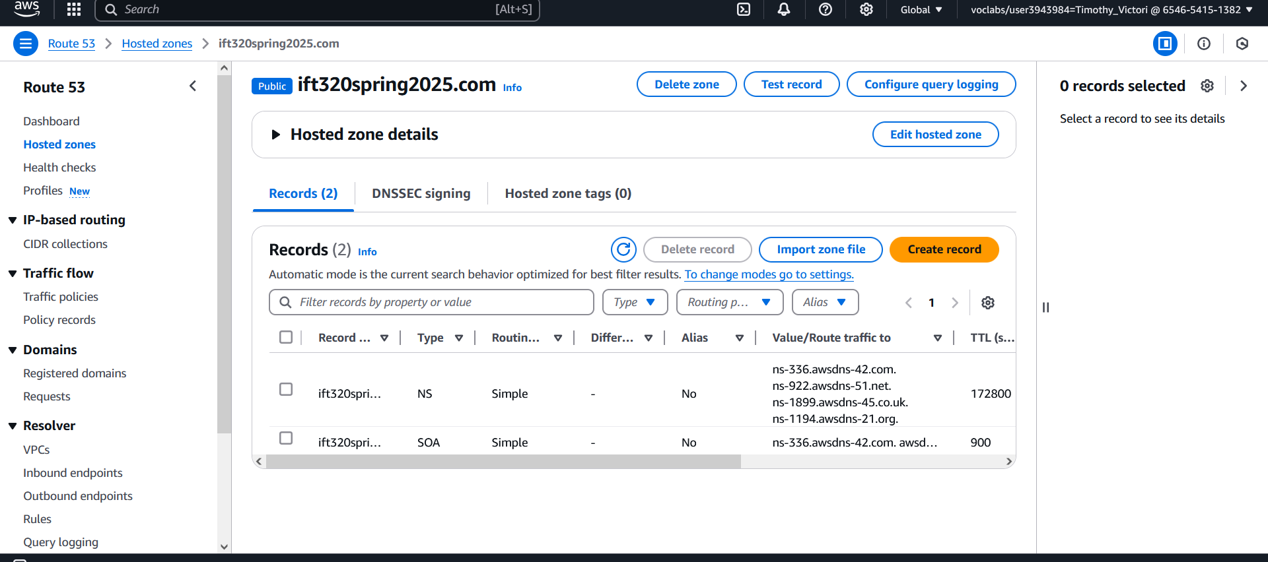

**Figure 21:**

*CloudWatch Metrics*

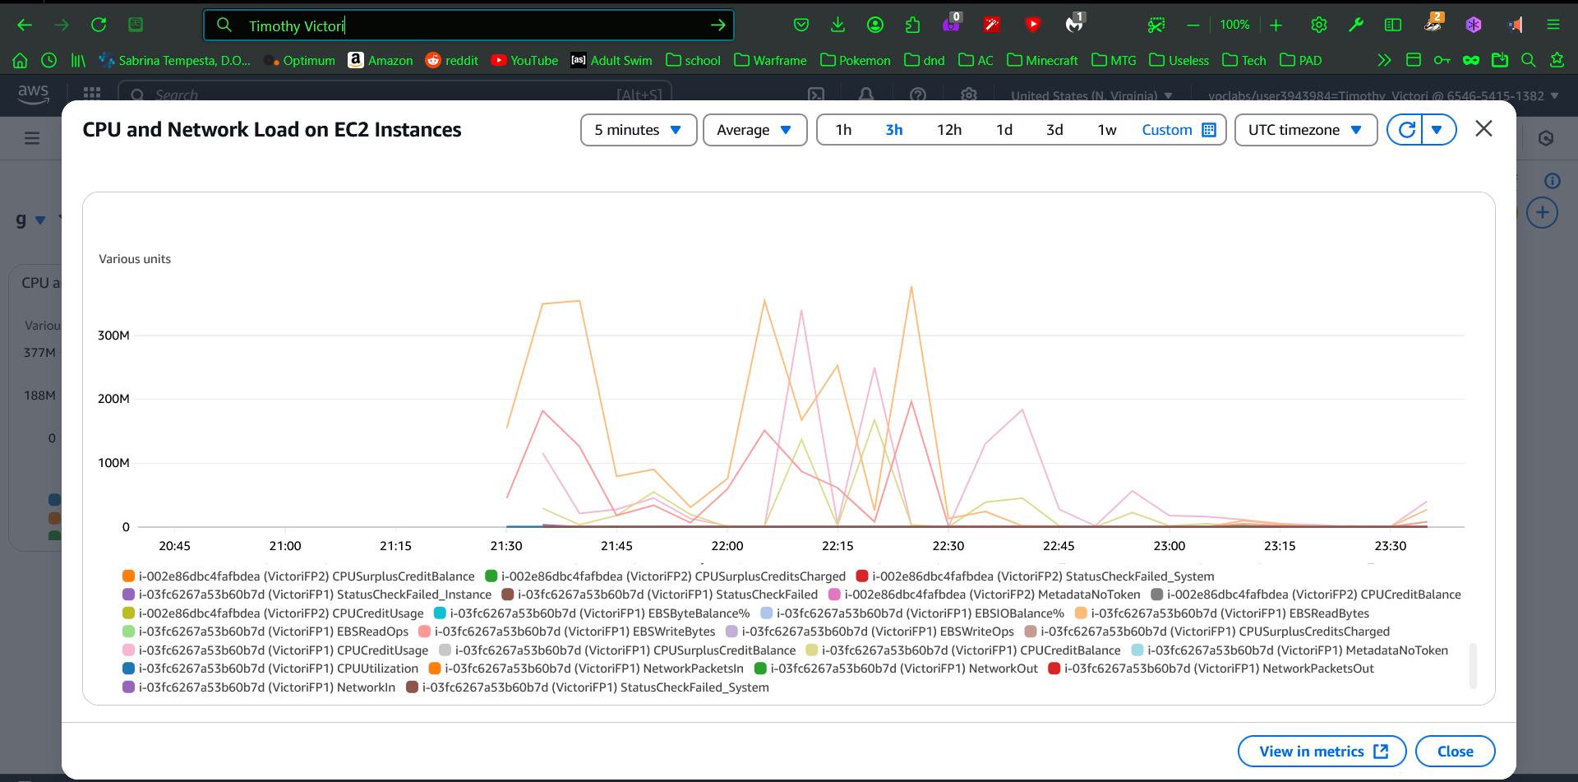

**Figure 22:**

*DynamoDB Table*

